SENG 272 - Software Project II: Individual Project
ISO/IEC 15939 Measurement Process Simulator - Requirements and Design Document
Student Name: Çiğdem TAPKAN
Student ID: 202127401
GitHub Repository: https://github.com/Cigdemtapkan/Seng272.git
Submission Date: 30.03.2026

1. Purpose of the Project
The purpose of this assignment is to develop a Java Swing desktop application that simulates the five core steps of the ISO/IEC 15939 software measurement process standard. The application facilitates defining quality dimensions, collecting metrics, and performing data analysis to support software engineering decision-making.

2. ISO/IEC 15939 Measurement Process
The project implements a simplified model of the international standard, following a systematic process from identifying information needs to performing analysis.
Step | Name | Description
1 | Profile | Entry of user and session information.
2 | Define | Selection of quality type, mode, and specific scenario.
3 | Plan | Display of predefined metrics and their attributes (read-only).
4 | Collect | Input of raw data and automatic calculation of 1-5 scores.
5 | Analyse | Weighted averages, radar chart visualization, and gap analysis.

3. System Requirements

3.1. Functional Requirements
- Step 1: Profile: The system must collect Username, School, and Session Name. It must validate that all fields are filled before proceeding, displaying user-friendly warnings if data is missing.
- Step 2: Define: Users must select exactly one Quality Type (Product/Process) and one Mode (Custom/Health/Education). Scenarios must be dynamically listed based on the selected mode.
- Step 3: Plan: The application must display dimensions and metrics for the selected scenario in a read-only table format, including coefficients, directions, and units.
- Step 4: Collect: The system will allow raw data input and calculate scores between 1.0 and 5.0, rounded to the nearest 0.5.
- Step 5: Analyse: Calculation of dimension-based weighted averages and identification of the lowest-scoring dimension for gap analysis.

3.2. Technical Requirements
- Language: Java SE 17 or higher.
- Library: Standard Java library only (Java Swing, Collections Framework).
- Structure: No IDE dependency; must be runnable via command line.

4. System Design and Architecture

4.1. Design Patterns
- Model-View-Controller (MVC): Logic/data classes will be strictly separated from GUI classes.
- Wizard Structure: Navigation between the 5 steps will be managed using CardLayout.
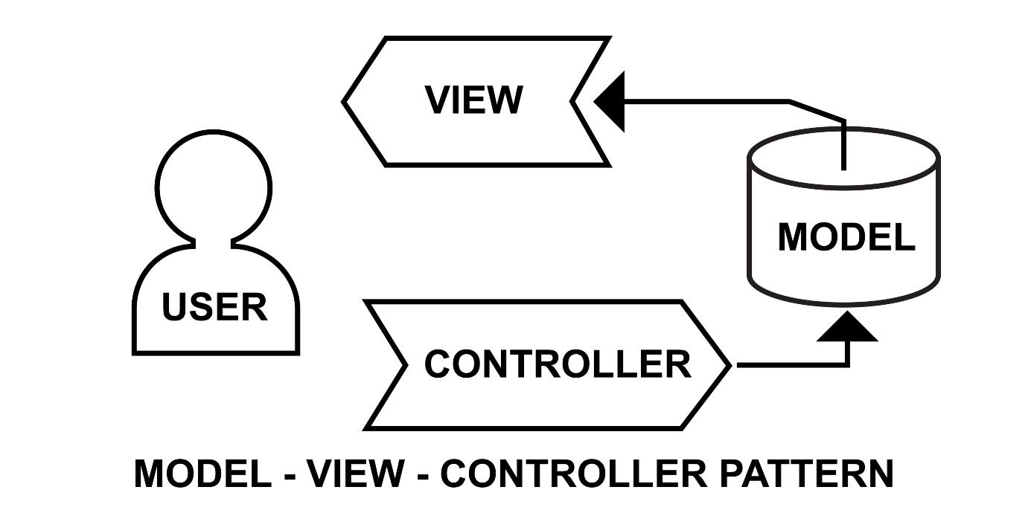
Shutterstock

4.2. Class Hierarchy
The application will utilize Object-Oriented Programming (OOP) principles including Encapsulation, Inheritance, and Polymorphism:
- Model Layer: Metric, Dimension, and Scenario classes to manage data centrally.
- View Layer: MainFrame (JFrame), StepPanel (Abstract JPanel), and specialized panels for each step (e.g., ProfilePanel).
- Controller Layer: Classes to handle event listeners and score calculations.

5. Mathematical Logic and Formulas

5.1. Metric Score Calculation
Scores are calculated based on the metric direction:
- Higher is Better:
$$score=1+\left( \frac{value-min}{\max{- min}}\right)×4$$
- Lower is Better:
$$score=5-\left(\frac{value-min}{\max{- min}}\right)×4$$

5.2. Dimension Score (Weighted Average)
$$dimensionScore= \frac{\sum{(metricScore ×metricCoefficient)}}{\sum{(metricCoefficient)}}$$

5.3. Gap Analysis
The gap is identified by the difference between the maximum possible score (5.0) and the dimension score:
- Gap value:
$$5.0-score$$

6. User Interface Design (Figma Mockups)
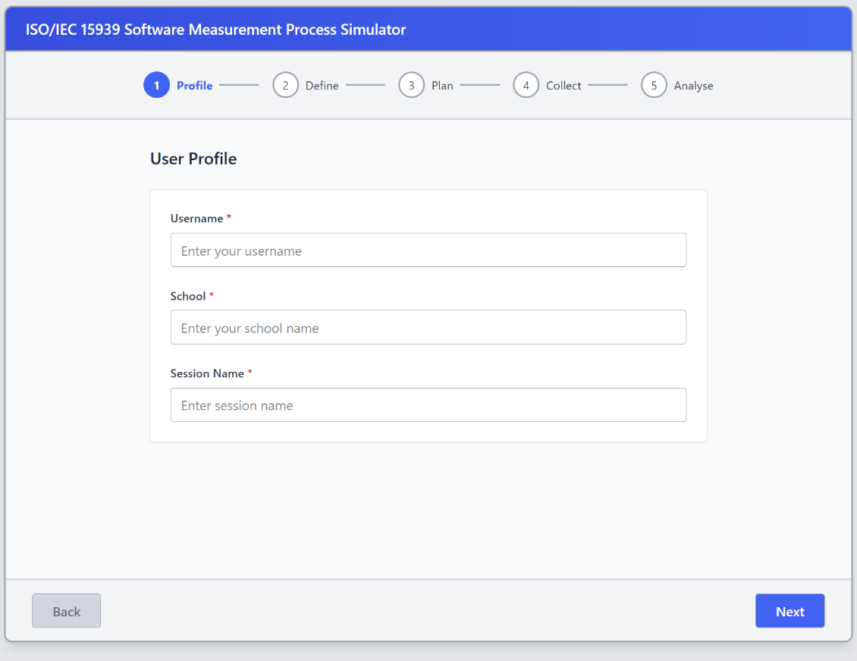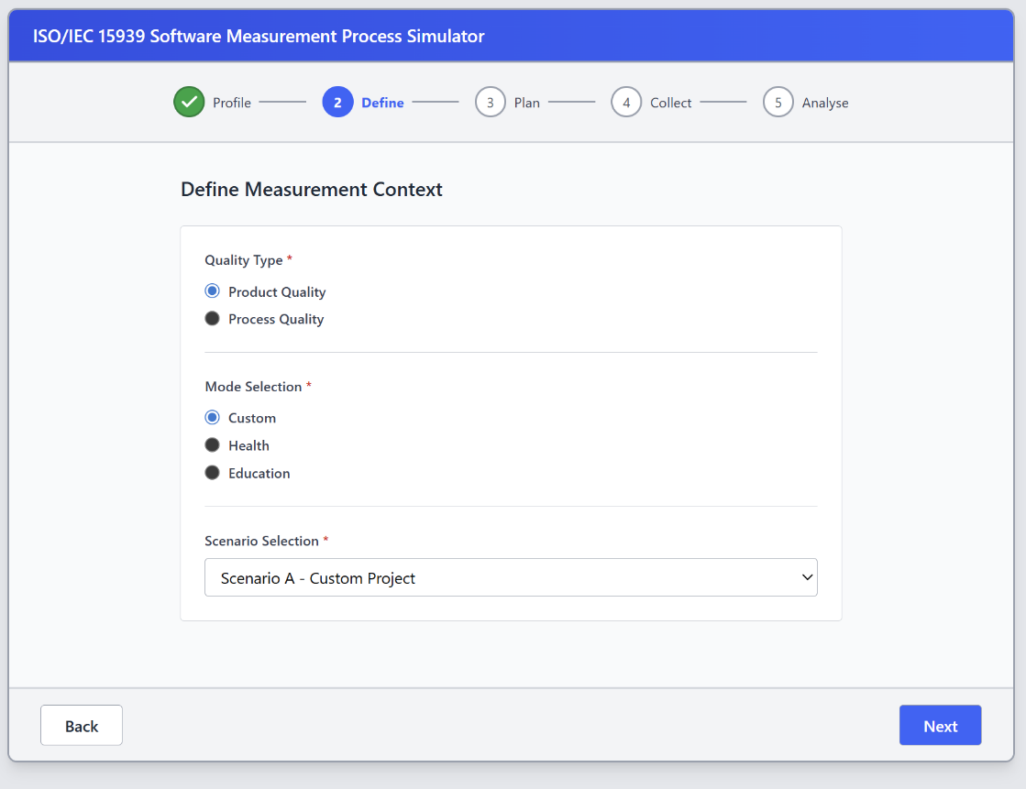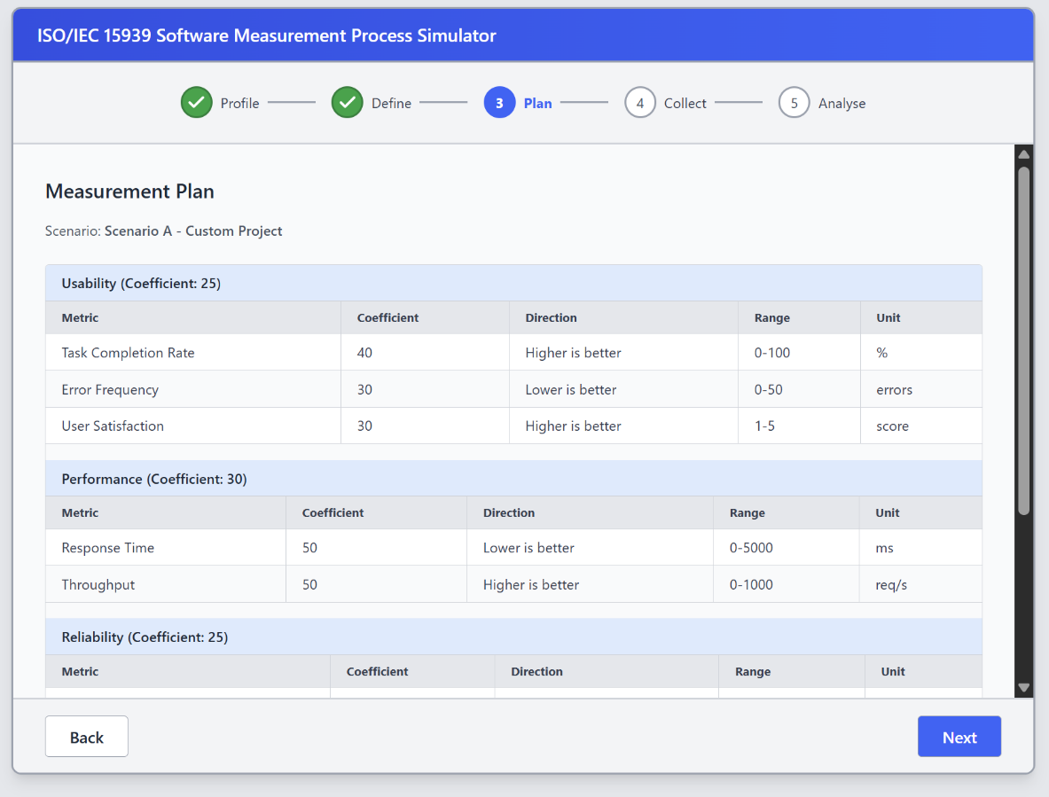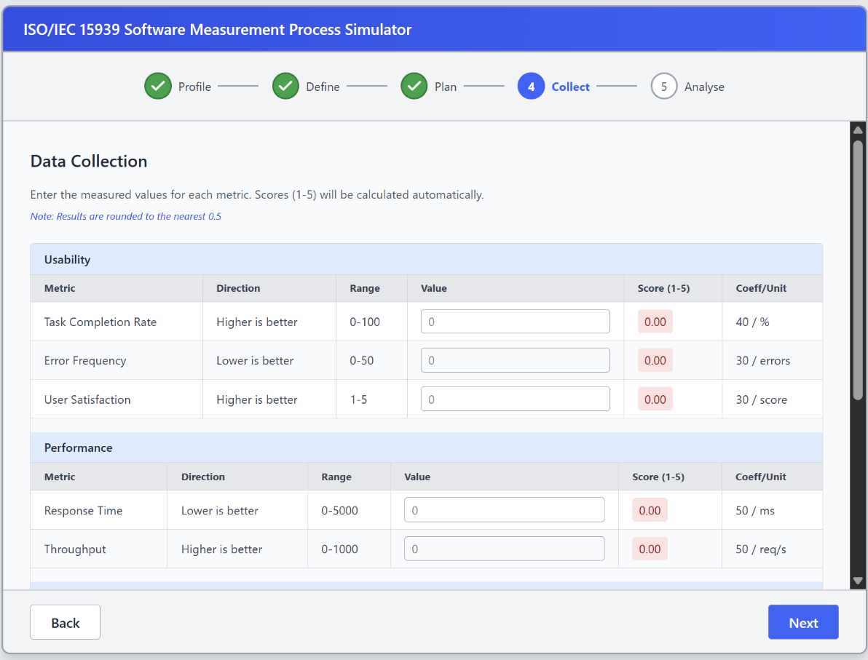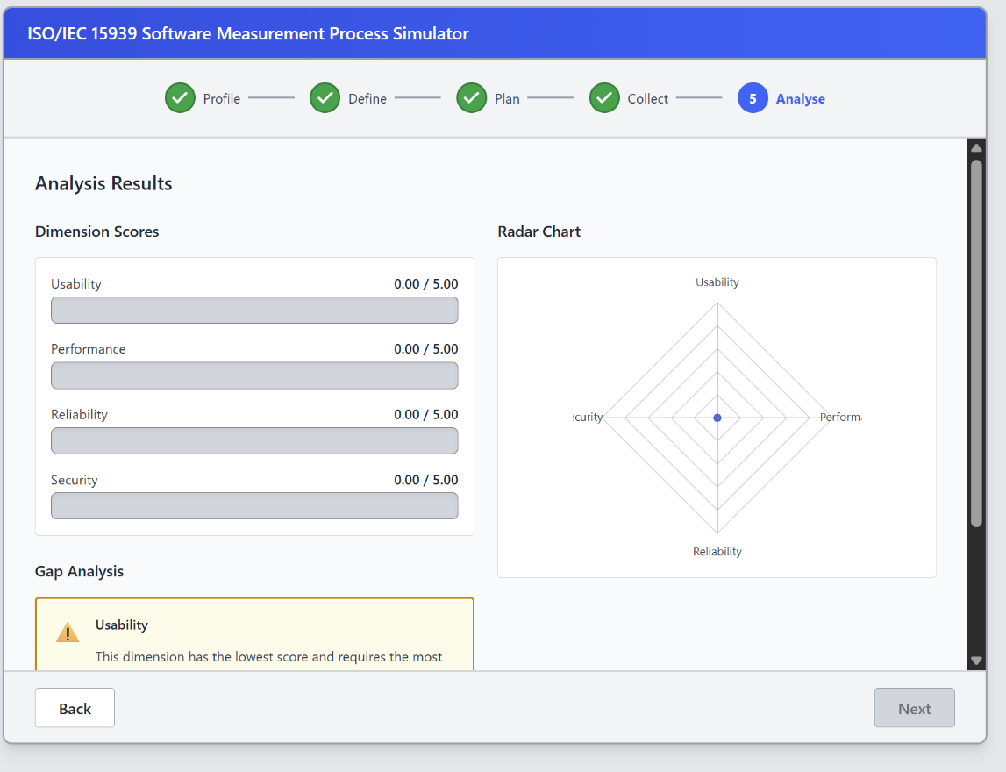
Step 1 - Profile Screen: Includes input validation and user-friendly warnings.
Step 5 - Analysis Screen: Features a Step Indicator, JProgressBars for scores, a Radar Chart (Bonus), and Gap Analysis labels.

7. Implementation Plan
The project will be pushed to a public GitHub repository with a complete commit history. Standard Java SE components like ArrayList and HashMap will be used for data management.

